# Poliygon API ETL

## Starting configs

* Config.ini:

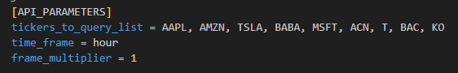

This config will query for that tickers info in an hourly bar.

* Checking empty DB table:

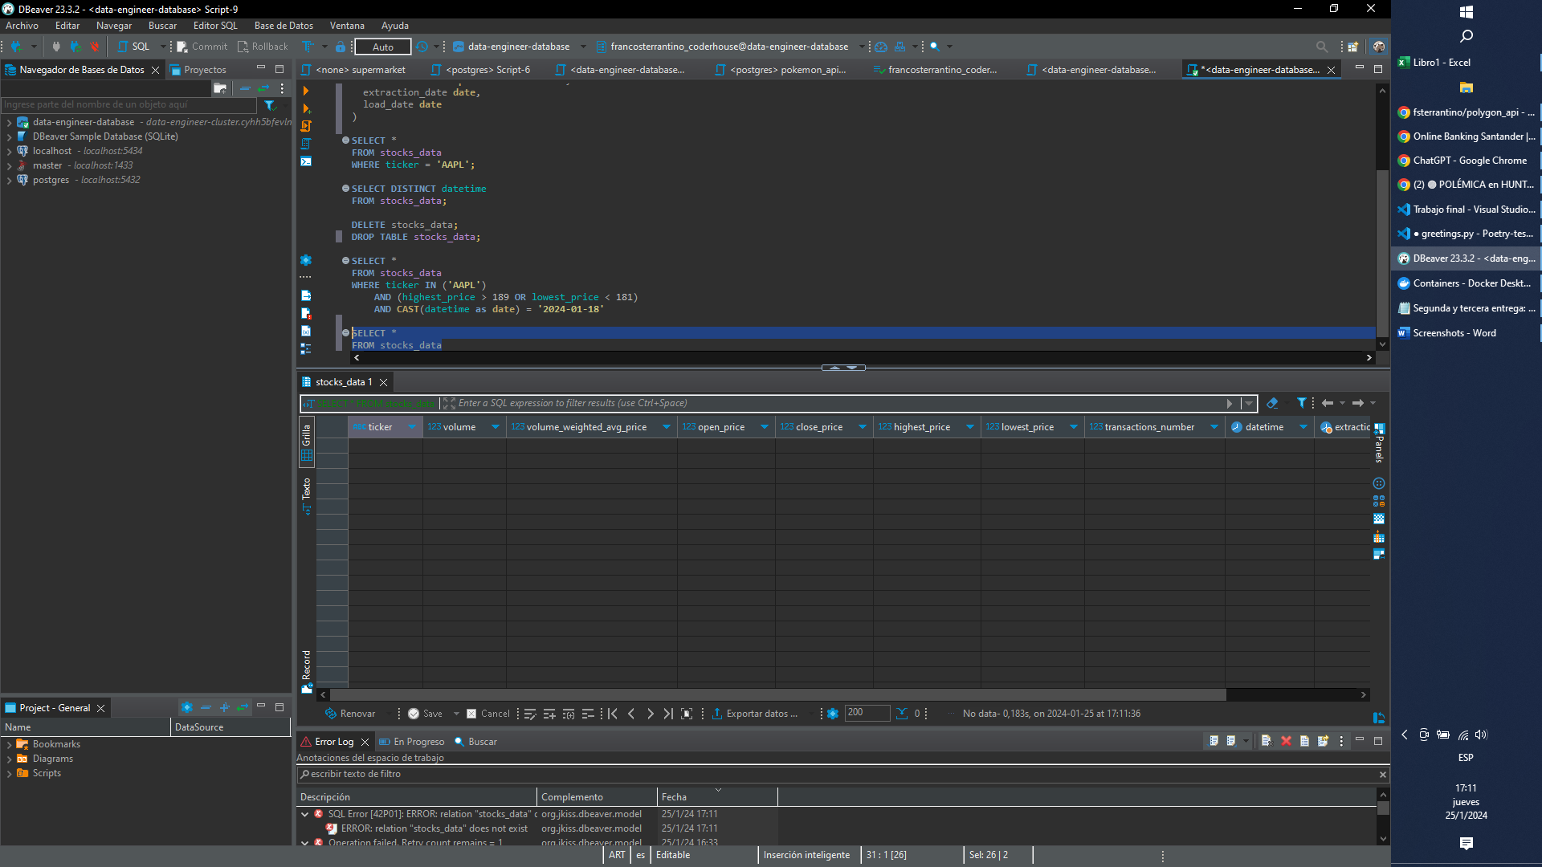

* Checking no containers in Docker:

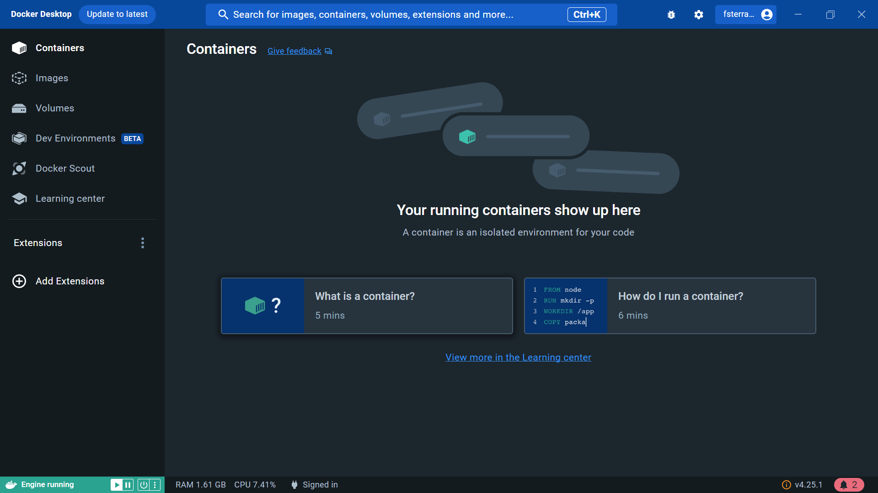

* Container started

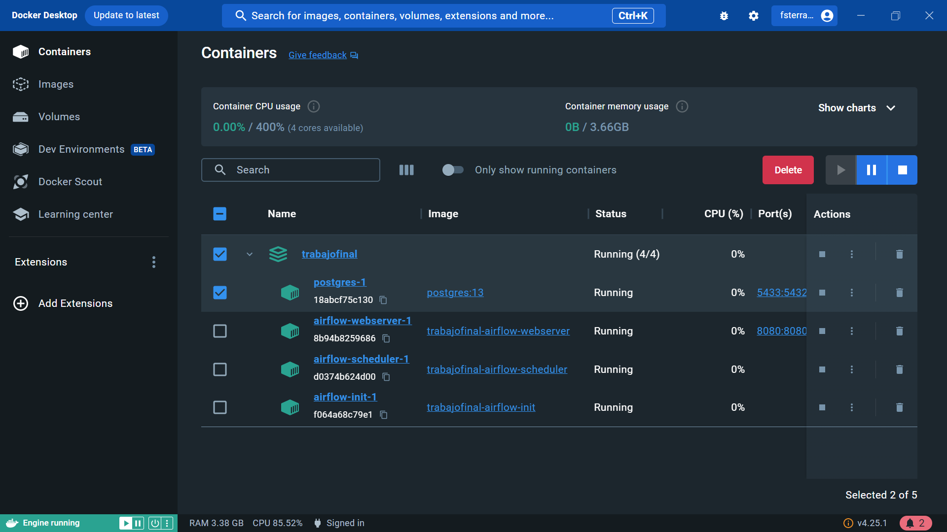

## Airflow

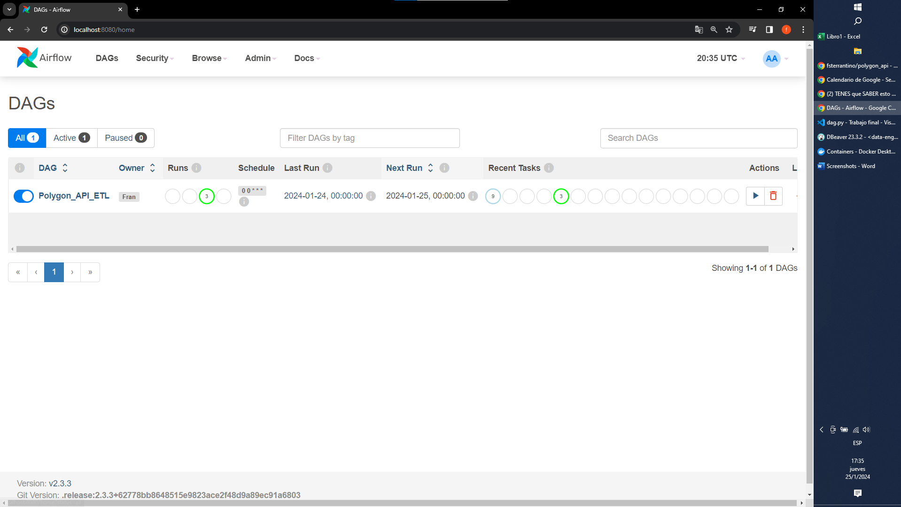

* Starting DAG execution (from startdate: 22/01/2024 to 24/01/2024)

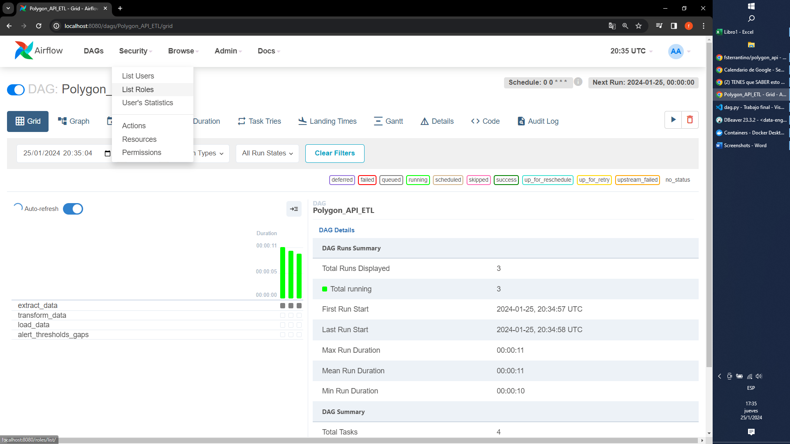

The expected result is the first transform to fail because it’s retrieving data from Sunday, when stocks markets are closed.

The extraction delays some time because the API has a rate-limit of 5 requests per minute.

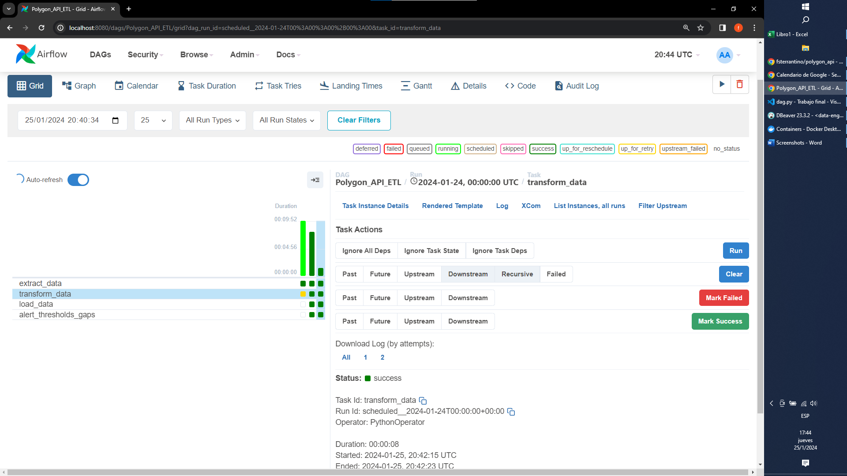

22/01/2024: Failed in transformation task as expected. The extraction did not generate the file as there is no activity on Sunday.

Extraction logs:

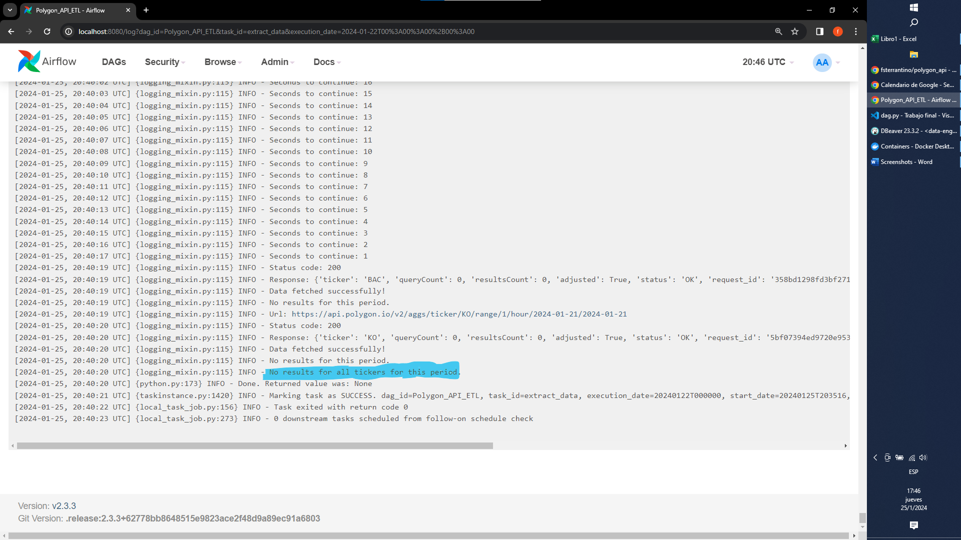

Transform logs:

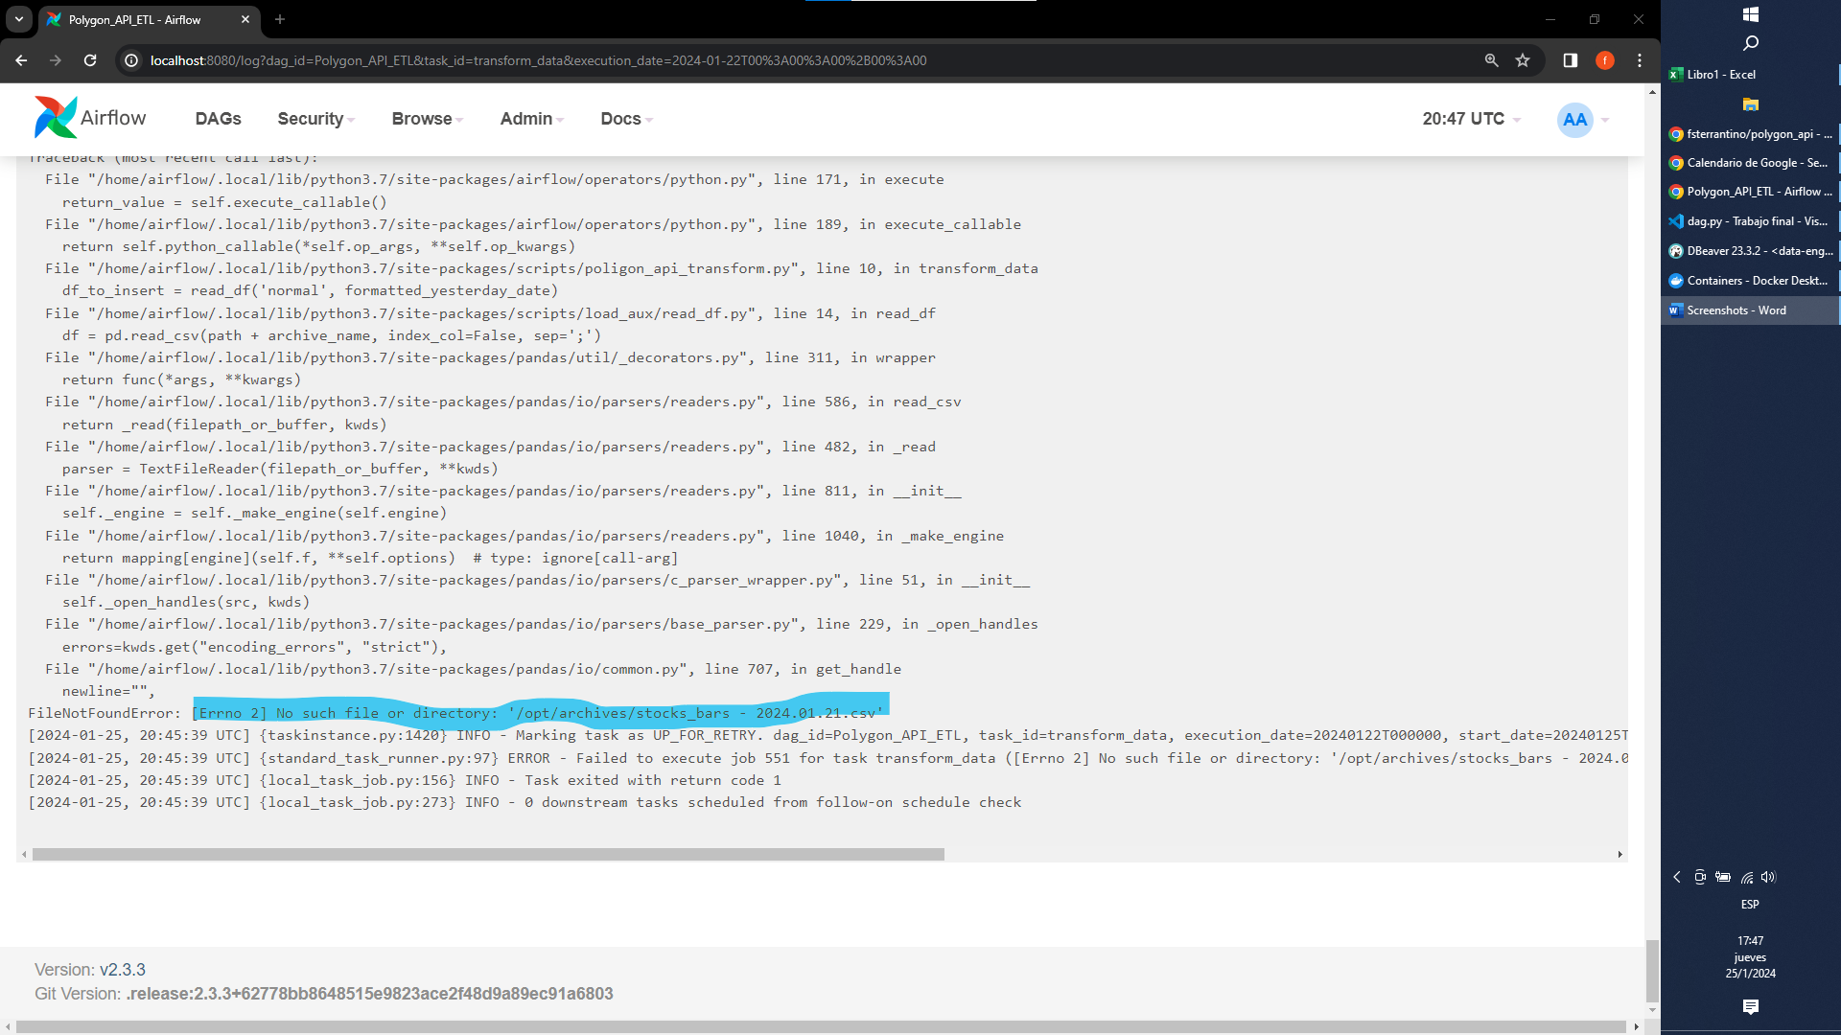

Load impact in DDBB:

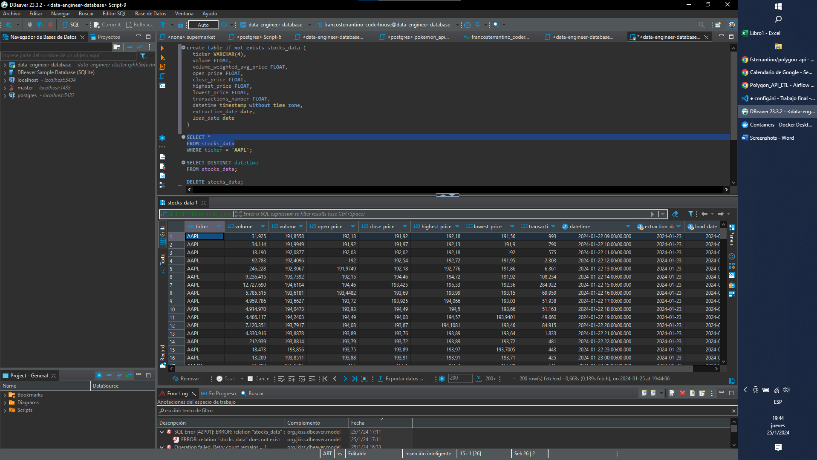

Distinct datetimes are: 22, 23, 24. As expected. We have some rows for January 24th because in the extraction of 23 it catches the Price for 24/01/2024 00:00:00.000.

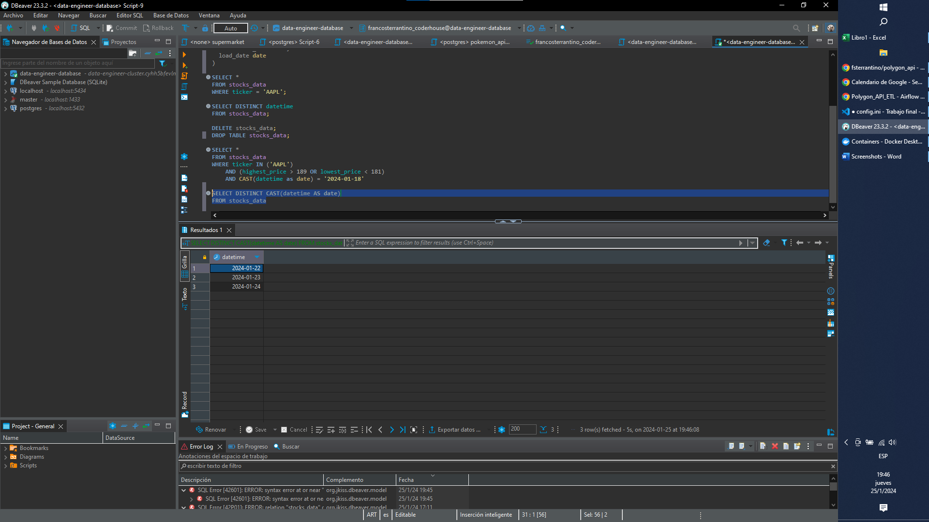

January 24th screen:

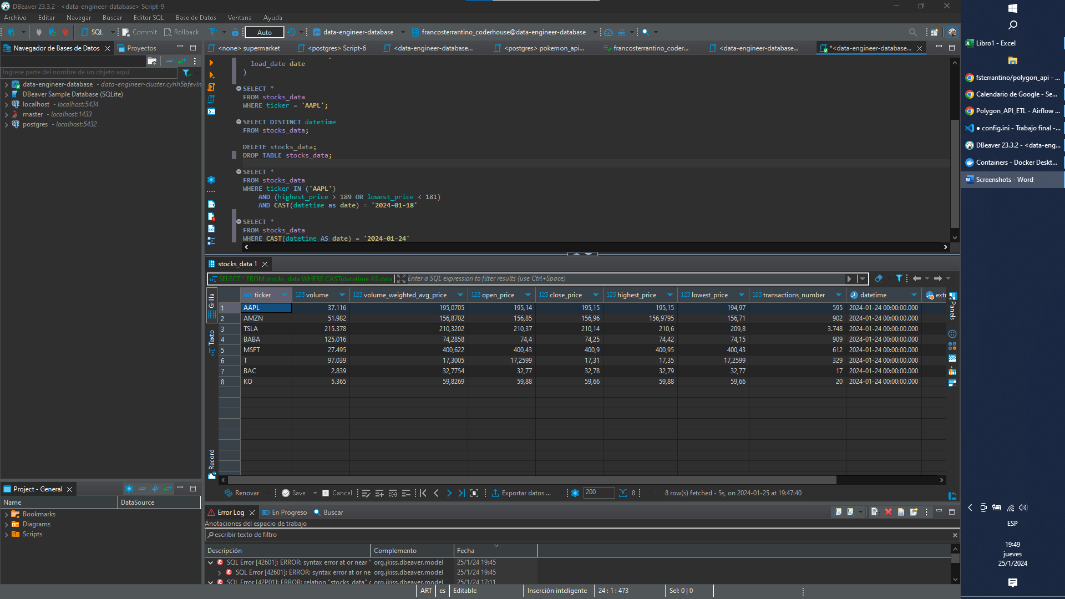

Checking distinct tickers: 9 tickers as expected.

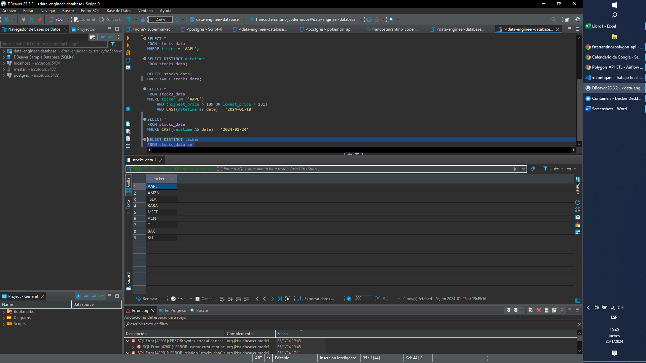

Alerted stock: I had to “clear” the tasks because one config.ini parameter was wrong. Decrease_threshold must be lower than 0.

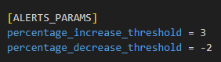

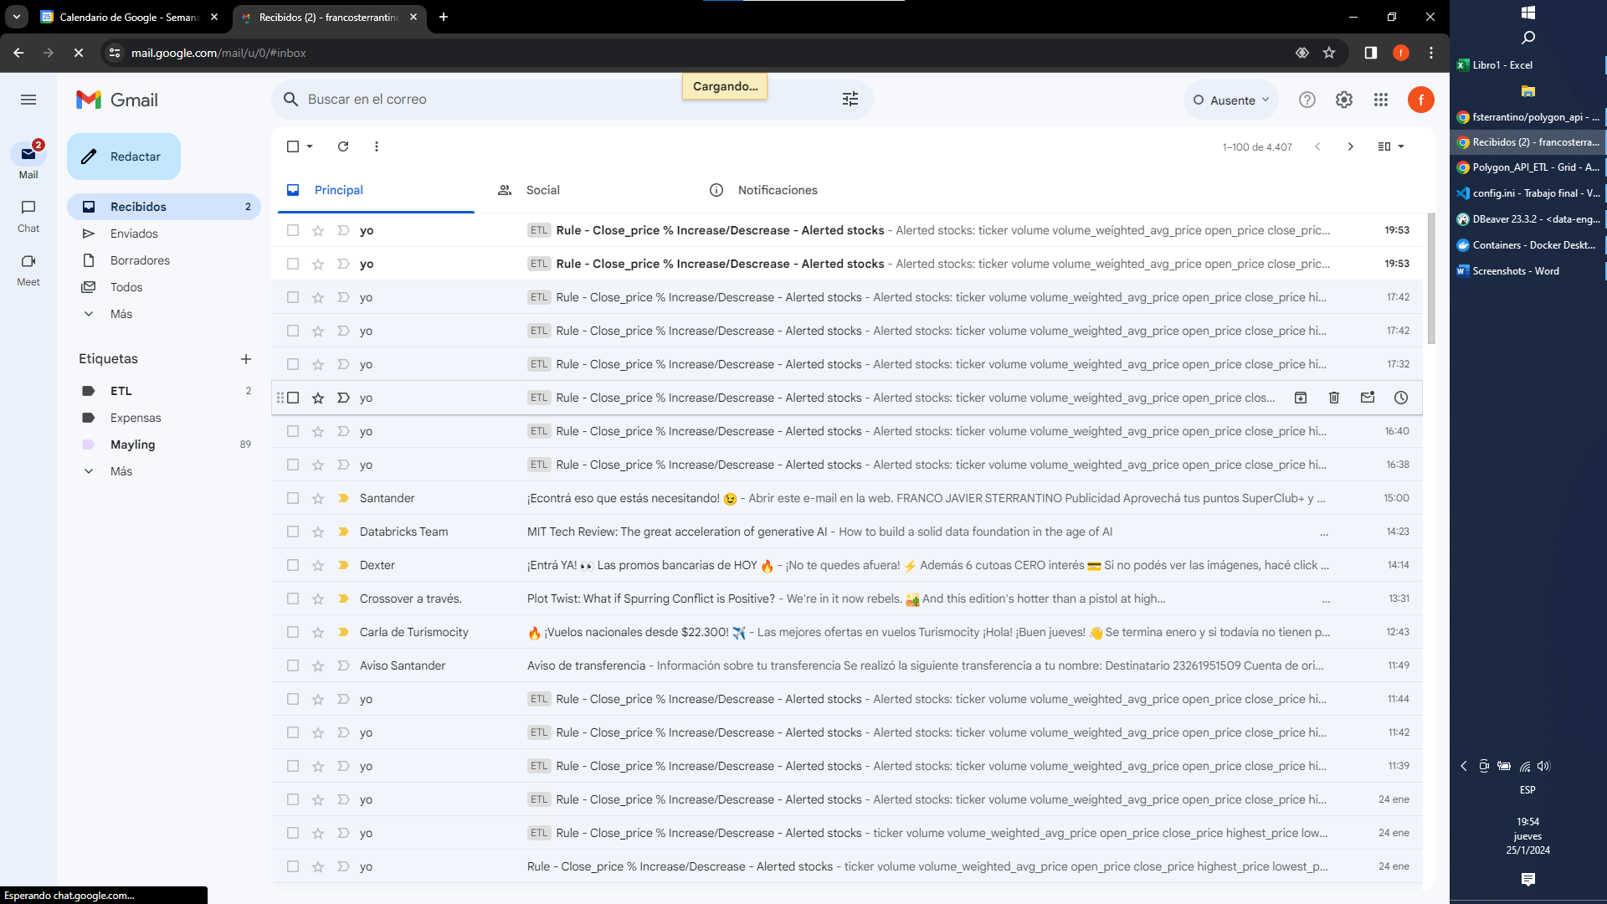

TLSA alerted on January 23rd. The stock Price moved from 216.9475 to 210.04 (-3.183950%). More decrease than the threshold (-2%).

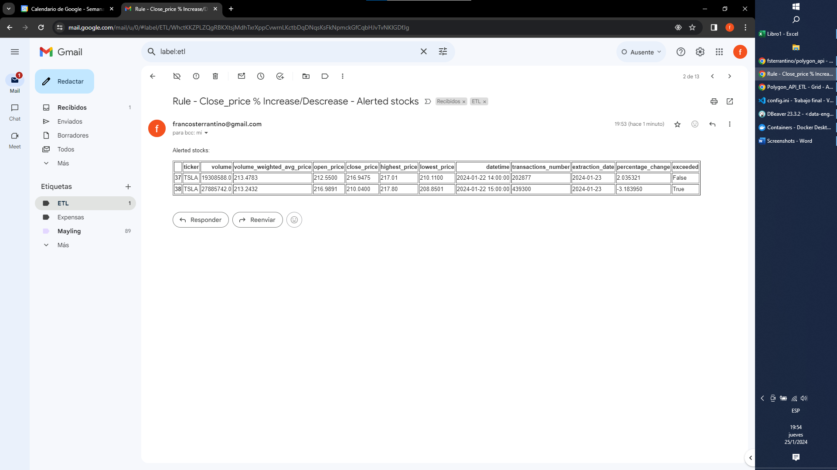

BABA alerted on January 24rd. The stock Price moved from 70.20 to 73.09 (4.116809%). More increase than the threshold (3%).

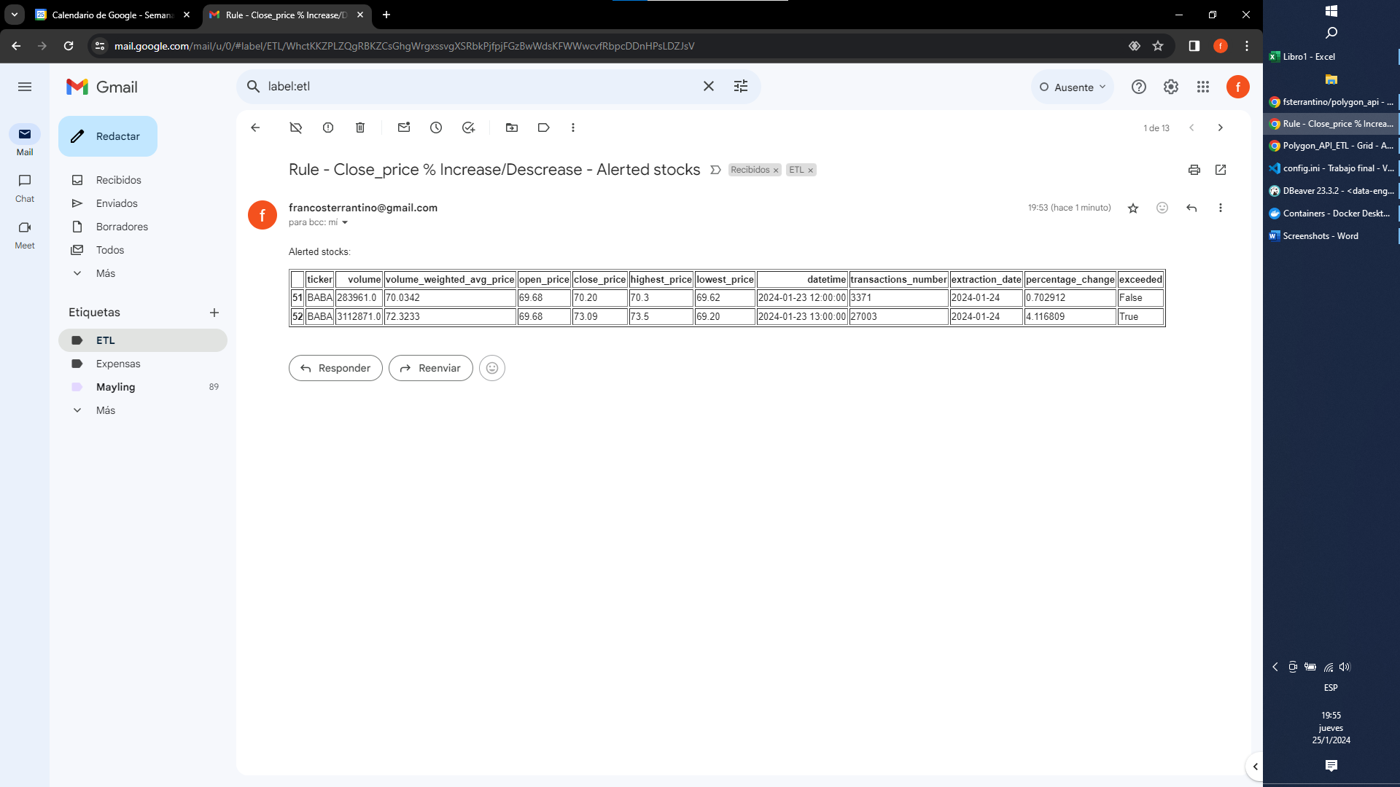

I downloaded a csv with the data loaded in the DB to check this control. The resulto f the script is correct:



Now, I would try to test the integrity control. With that objective, I modificated the file that it’s loaded on January 22nd.

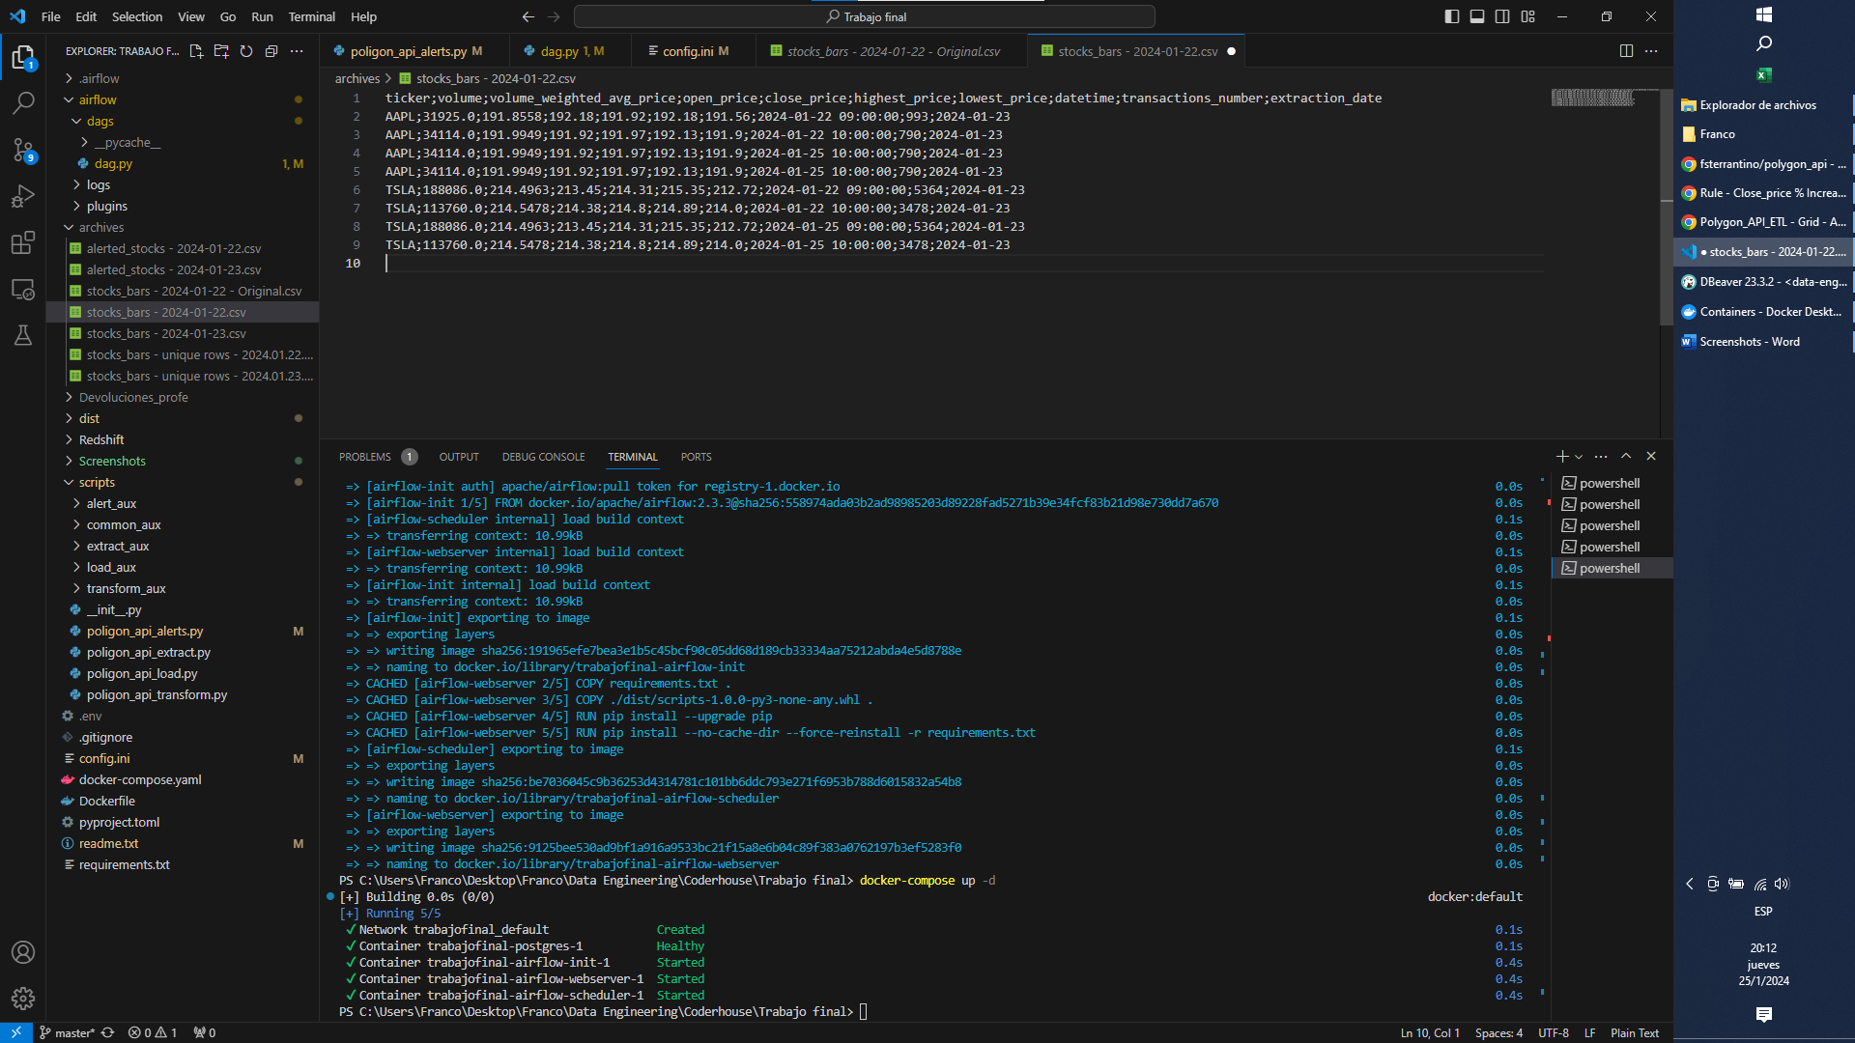

The first two rows of AAPL and TSLA, are the original ones, and they must be denied.

The other rows, are a copy with the datetime modified to 2024-01-25, in order to pass the control and be inserted.

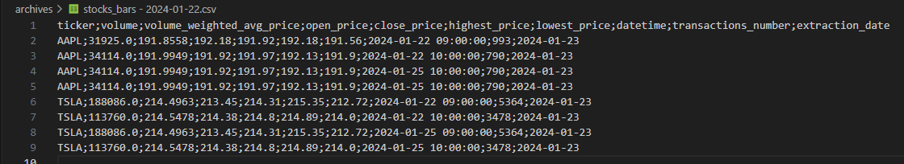

We can check that red rows are effectively loaded right now:

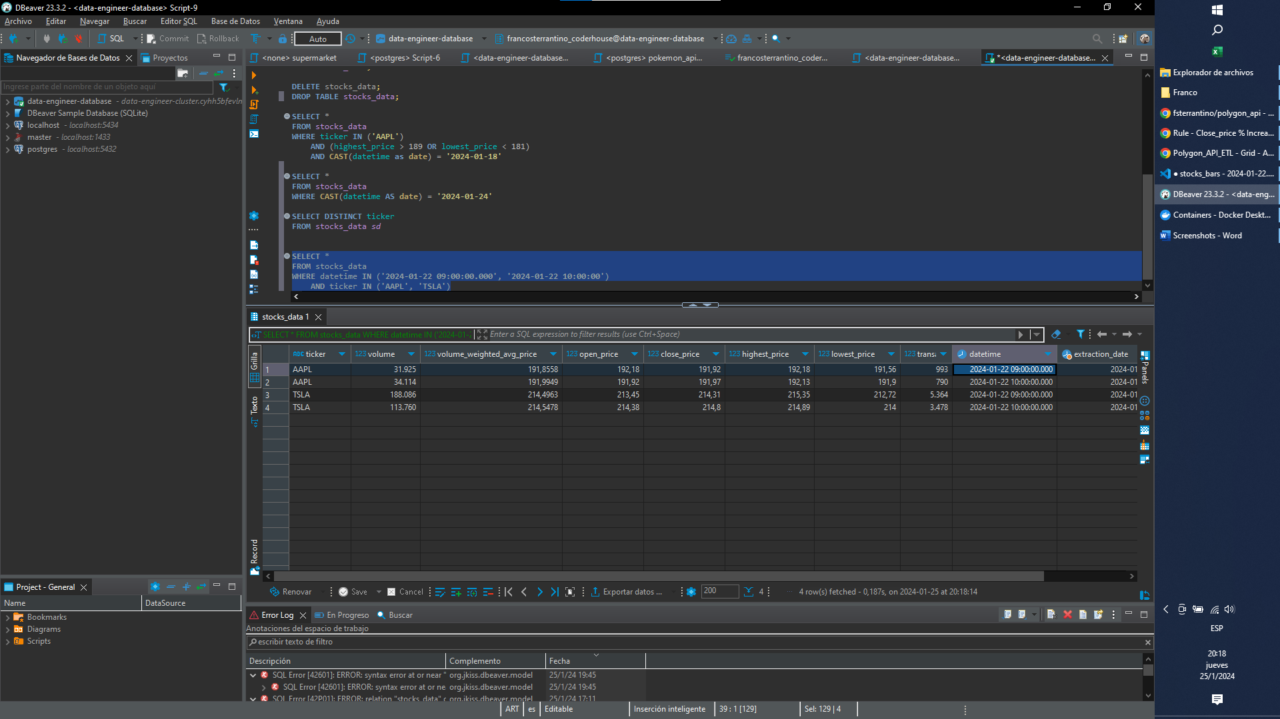

I replaced the file in the Docker container:

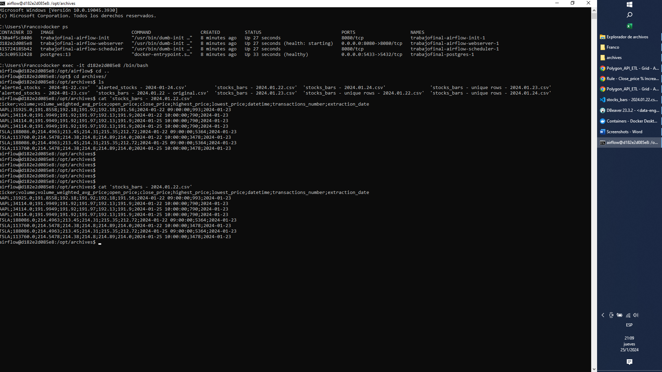

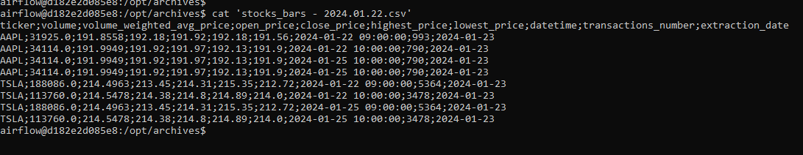

Now I’m going to clear the transform task from January 23rd (with info of 22nd) in order to re-execute it.

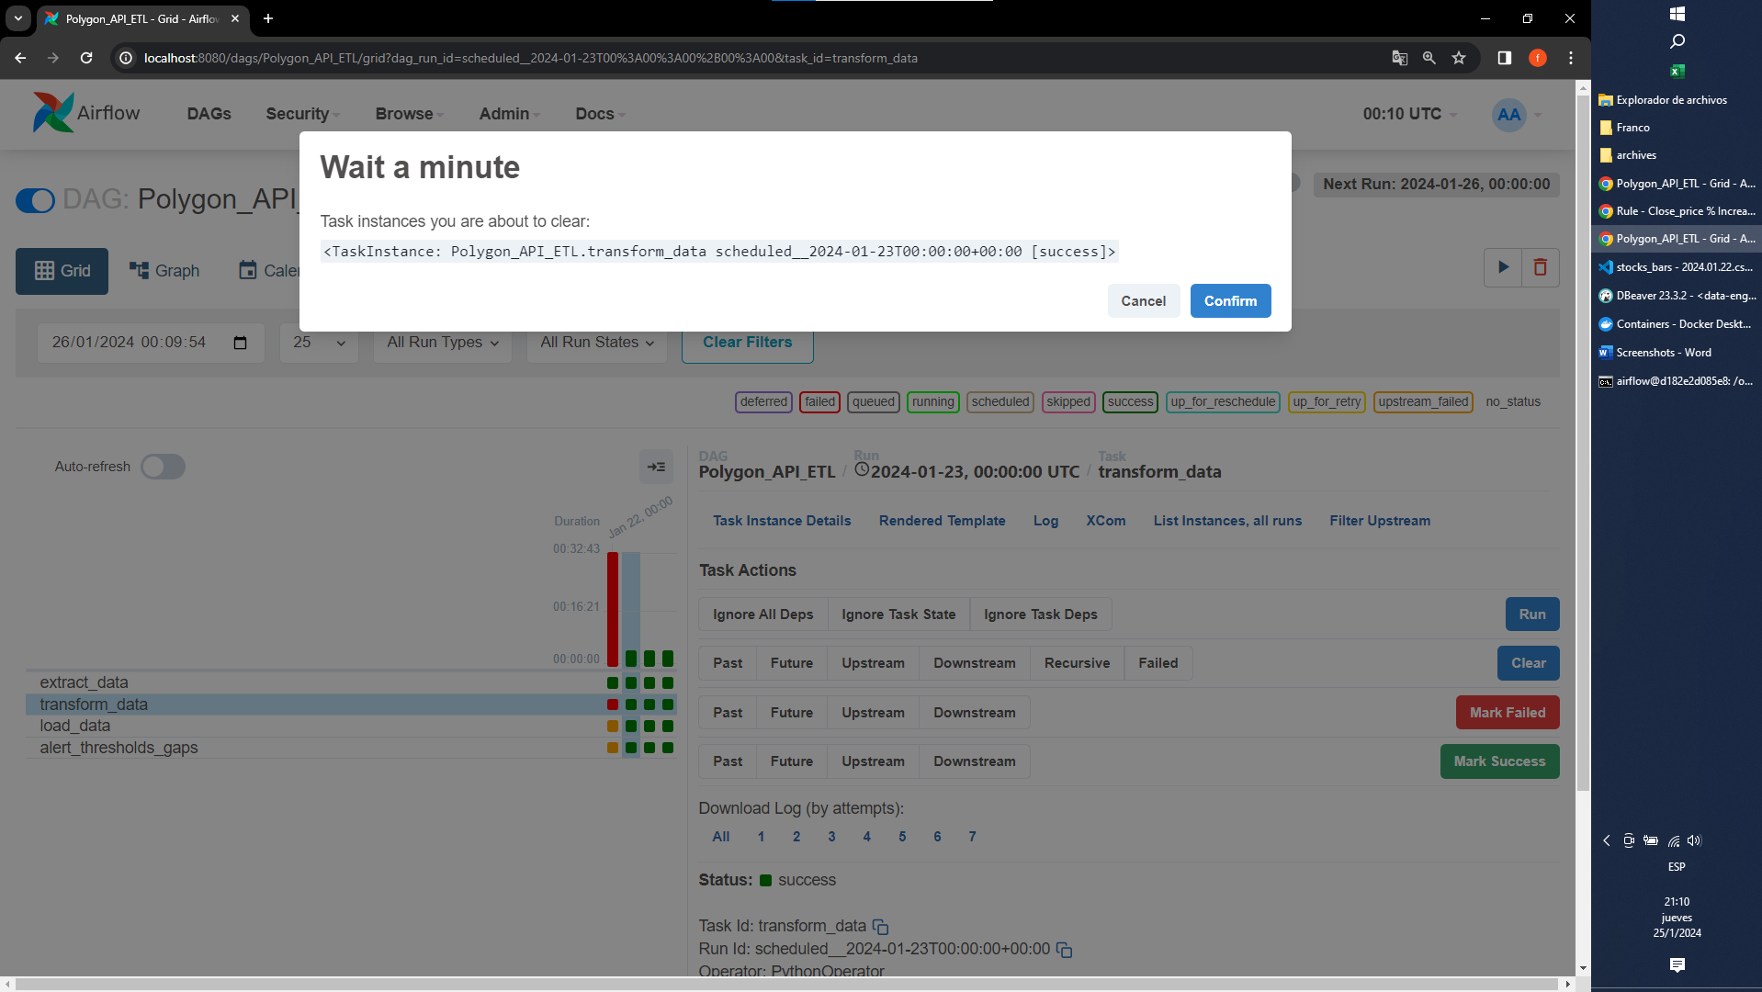

It finished with successful state:

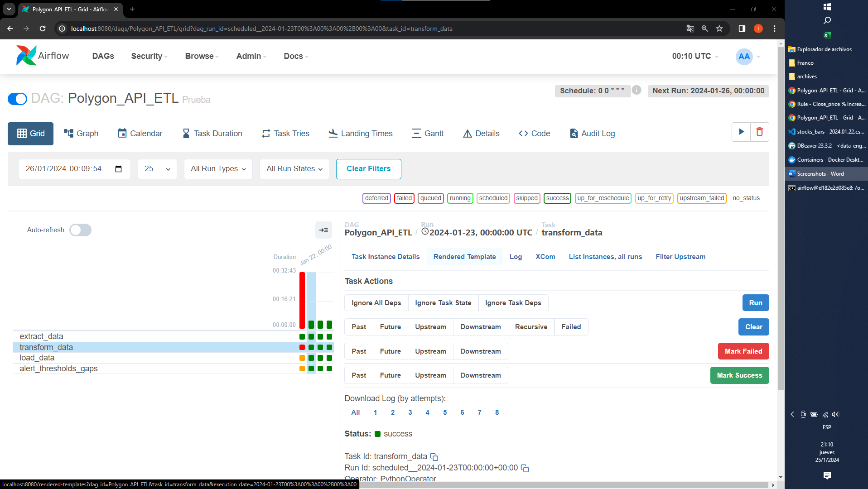

Let’s see the logs:

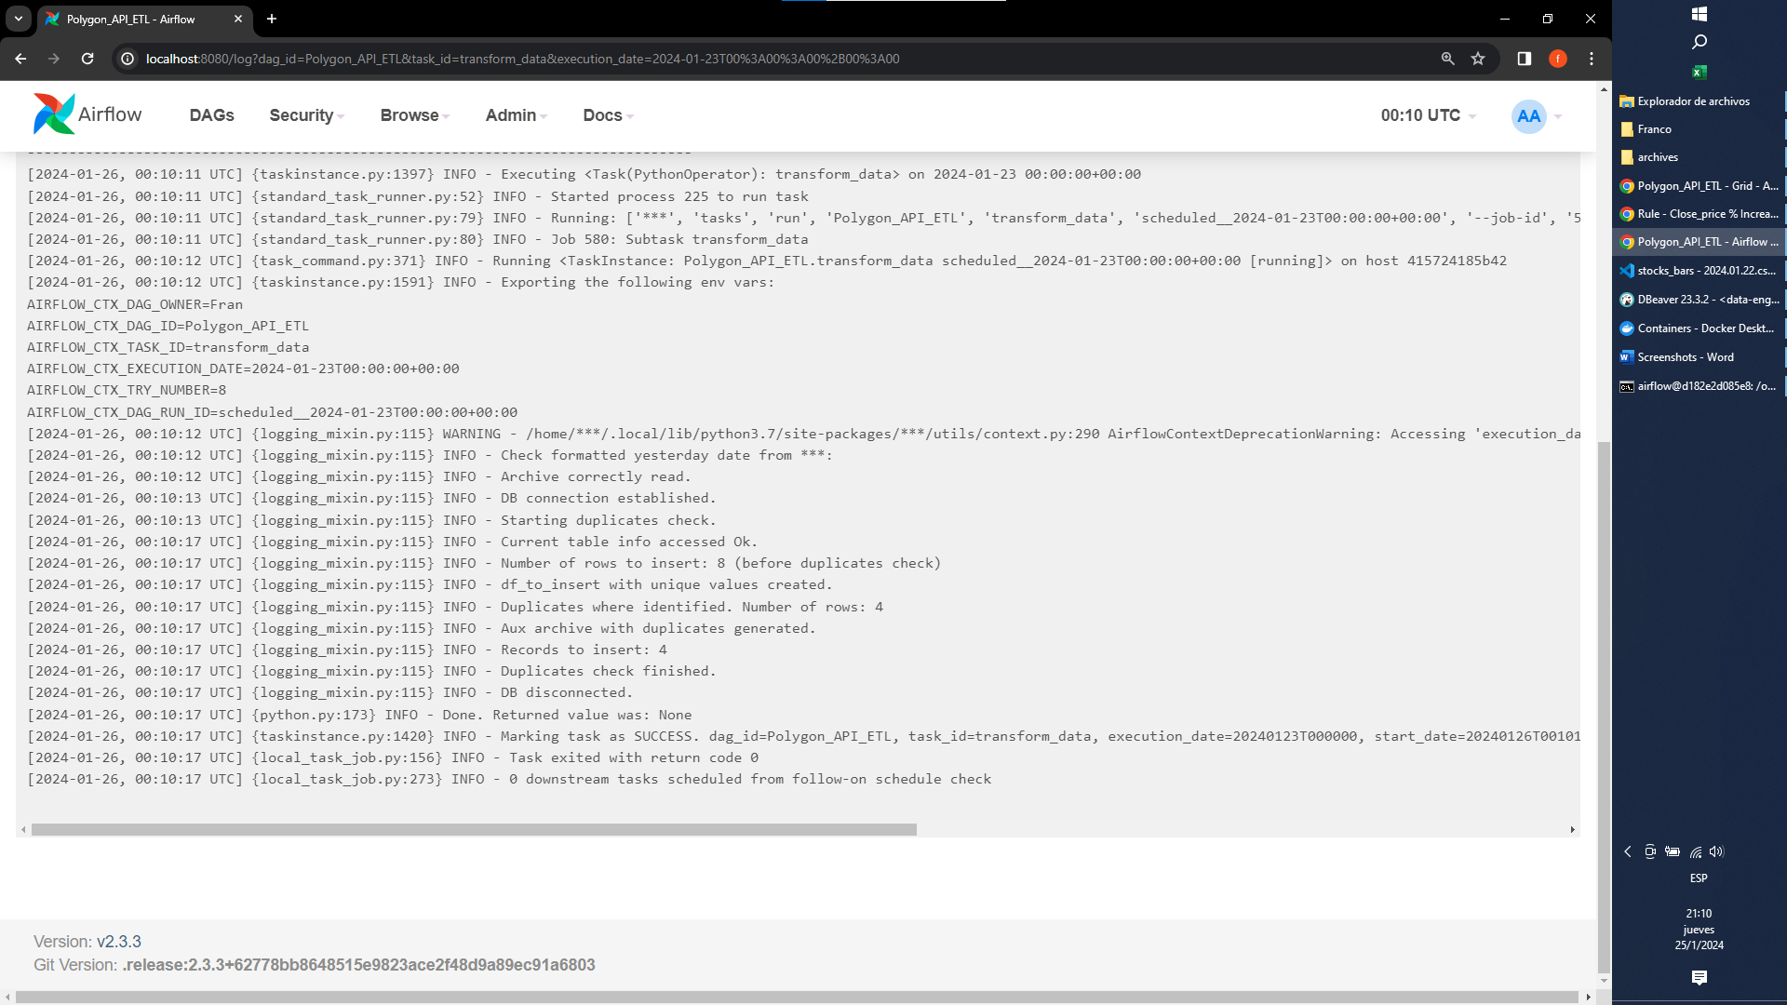

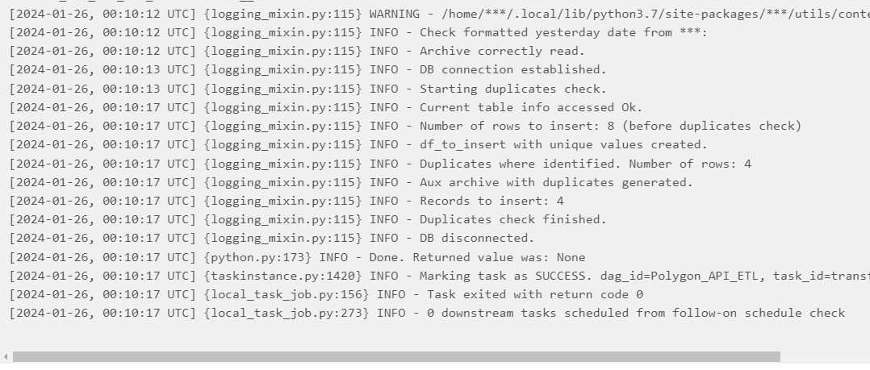

It detected successfully the 4 rows duplicated. Let’s see them in the file generated:

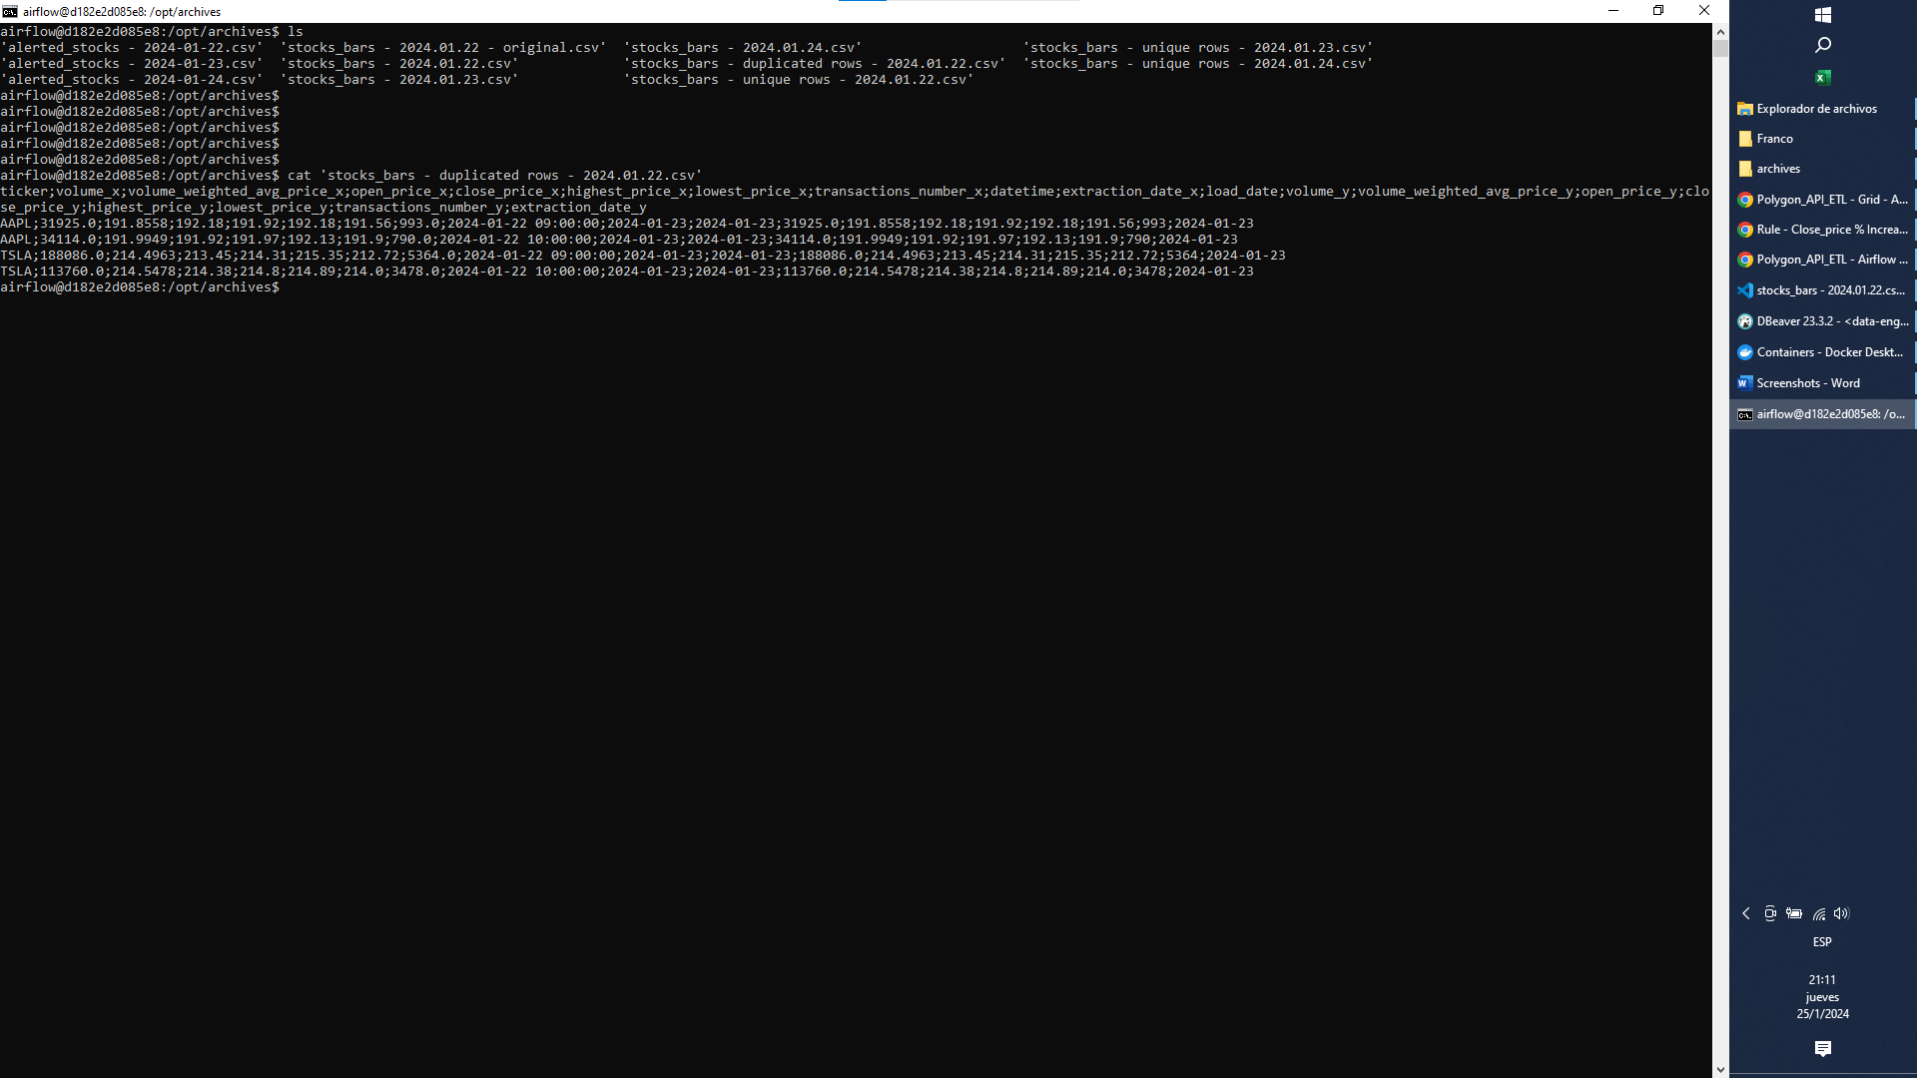

We can see the 4 duplicated rows:

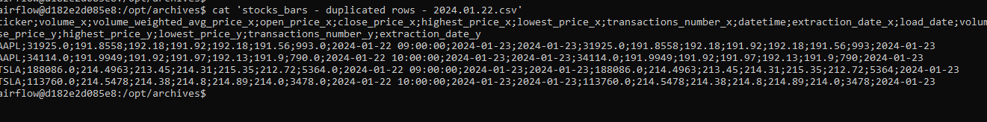

And finally we can check the DB:

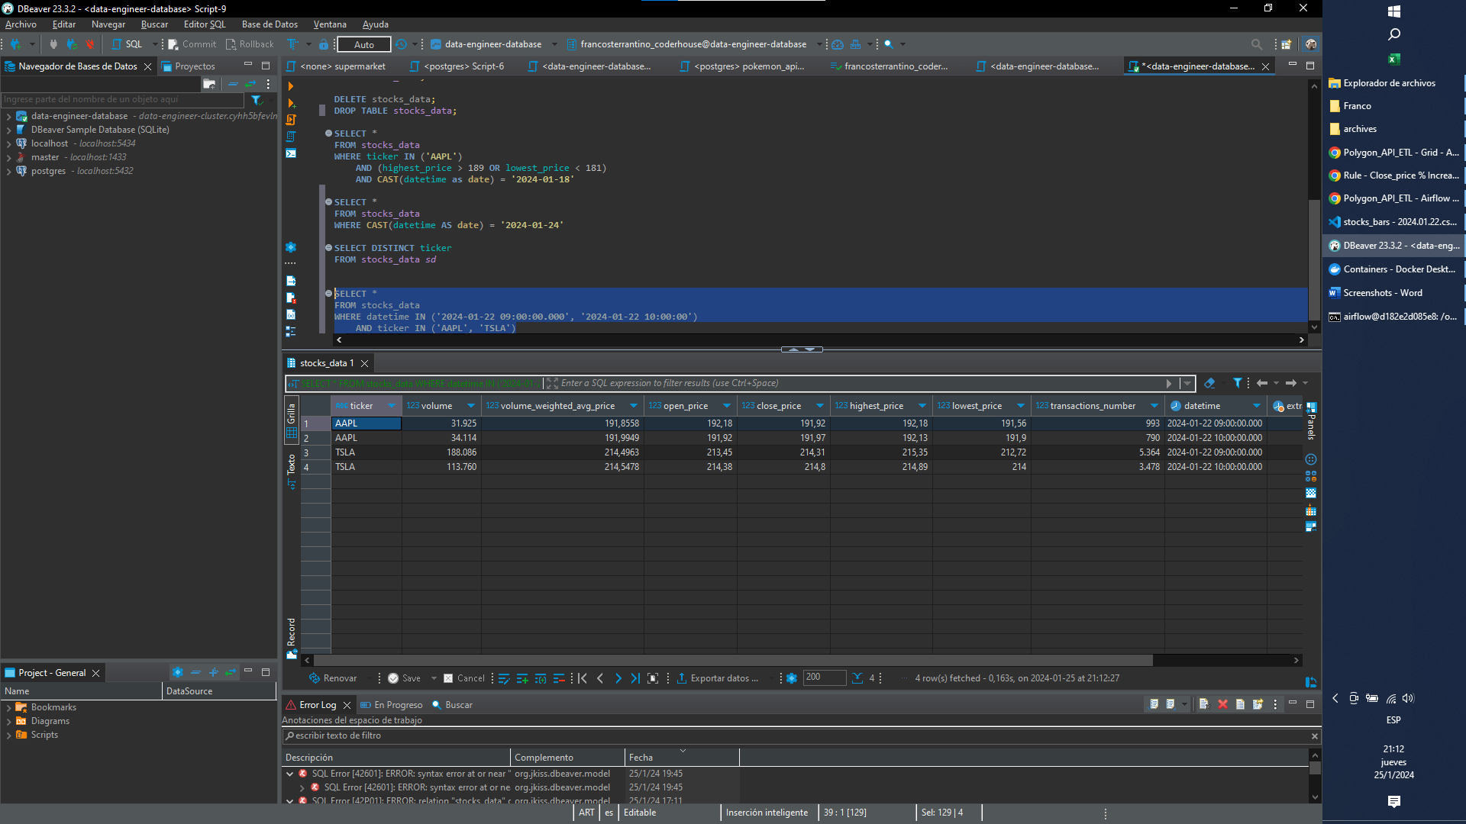

The query used before continues giving us the 4 original rows:

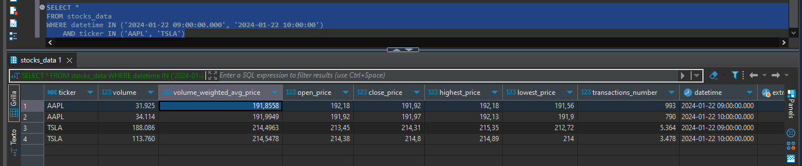

The four additional rows are not inserted because the load task was not executed:

